**PROJECT : Build an End-to-end data pipeline using Azure Data Factory**

* **Authentication**: SQL Server Authentication
* **Server name**: nallagah1.database.windows.net

|  |  |  |
| --- | --- | --- |
|  |  |  |

**MAIN LINK :**<https://witty-meadow-04aa4d610.5.azurestaticapps.net/>

# EXPLANATION

1. **Objective:**

The project aims to gather and present a "Student Count by Country" by extracting data from an SQL Server database. The primary objective is to showcase how SQL can be used to group data based on specific categories, in this case, the country of students, and then count the total number of students from each country.

1. **Tools Used:**

* SQL Server Management Studio (SSMS): Used to run SQL queries and manage the database.
* Azure SQL Database: The data is stored and processed in a cloud environment, utilizing Azure services.

**3. Implementation Steps:**

* Step 1: Connect to the Azure SQL Database via SQL Server Management Studio.
* Step 2: Query the student database to group data by country and count the number of students from each country using the SQL query.
* Step 3: Execute the query and review the results.

**4. Results:**

The query returns a list of countries with the corresponding number of students. For example:

* Bangladesh: 1 student
* Brazil: 9 students
* Canada: 7 students
* China: 13 students
* Germany: 1 student
* A total of 31 rows of results were displayed, showing student counts from different countries.

# COST ANALYSIS

1. **Total Projected Monthly Cost:**

The forecasted monthly cost for Azure services is **$10.94**, based on usage trends as of September 2024.

1. **Breakdown of Azure Service Costs:**

Storage: $0.17

Azure Data Factory (v2): $0.17

Bandwidth: < $0.01

Azure App Service: < $0.01

Functions: $0.00

**3.Regional Costs**:

* + **US Central**: $4.37
  + **CA Central**: < $0.01

## SS 1:- AZURE PORTAL LOGIN

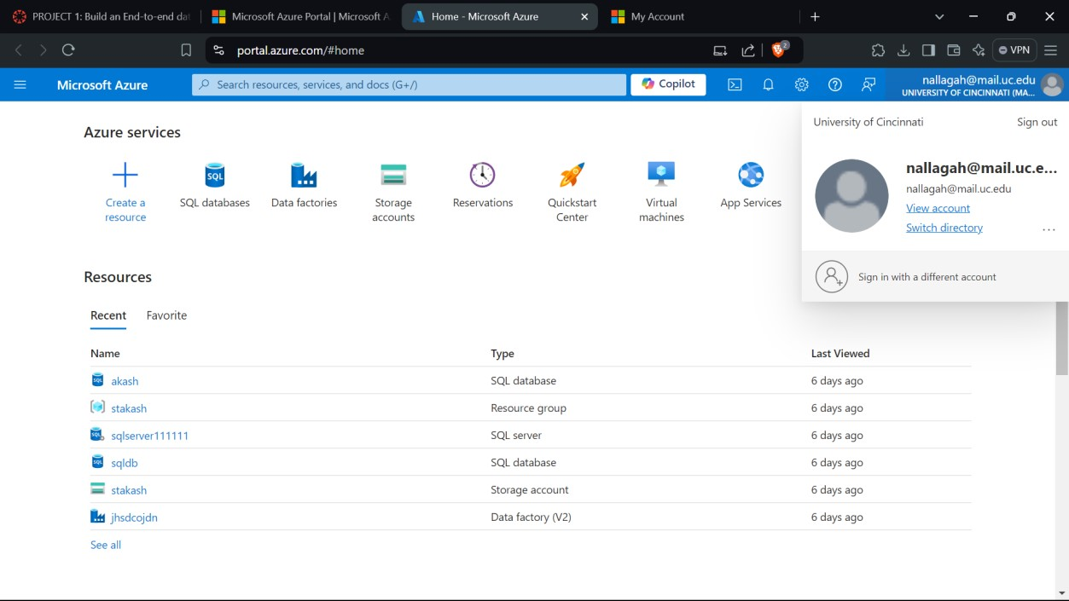

## SS 2:- CREATION OF STORAGE ACCOUNT

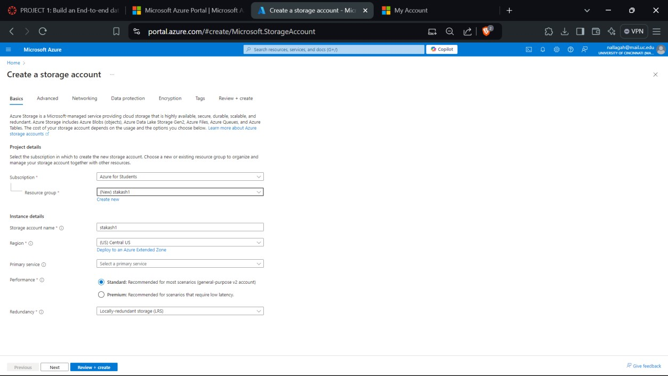

## SS 3:- DEPLOYMENT SCREEN OF STORAGE ACCOUNT

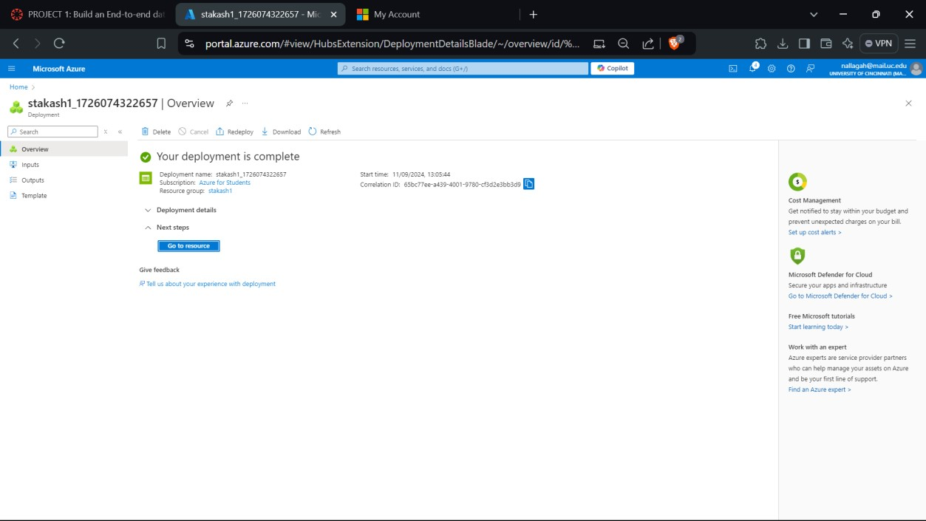

## SS 4:- CONFIGURATION SCREEN OF STORAGE ACCOUNT

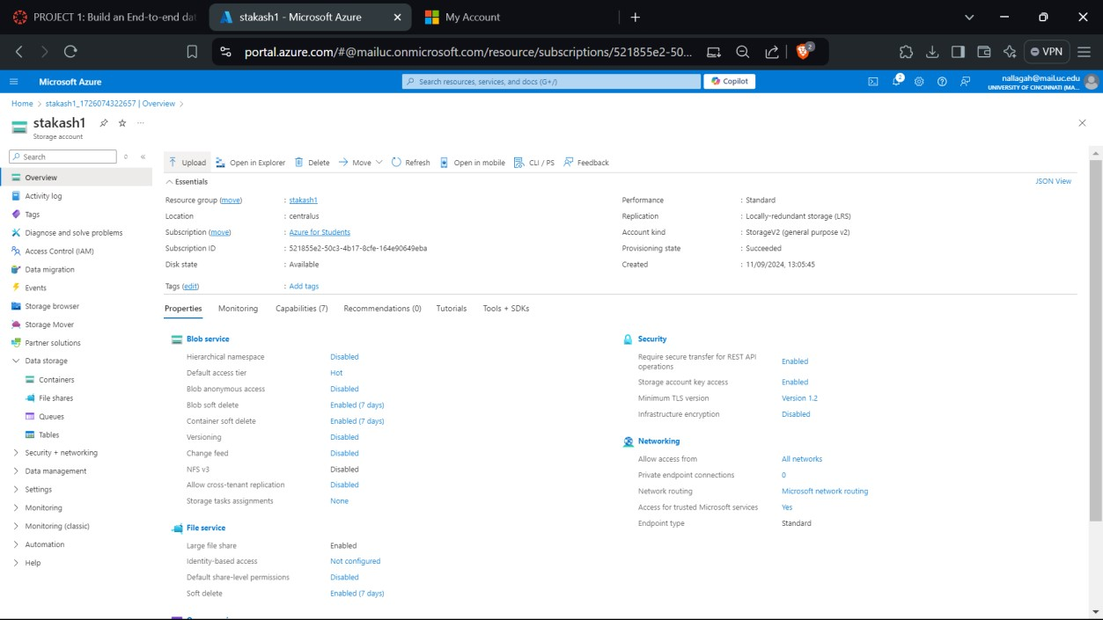

## SS 5:- CREATION OF STORAGE CONTAINER

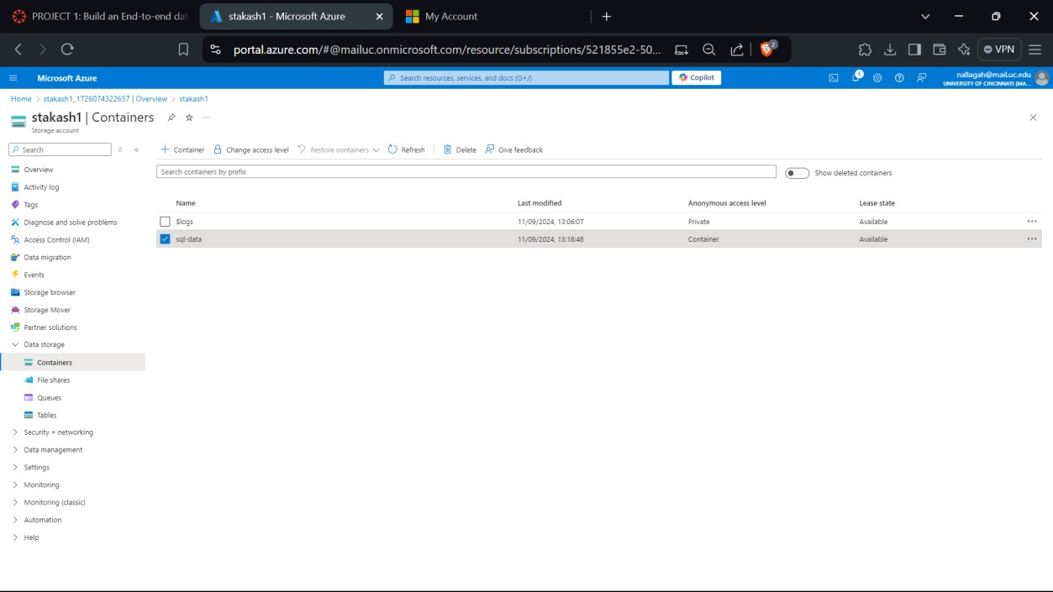

## SS 6:-CRETION OF SQL DATABASE

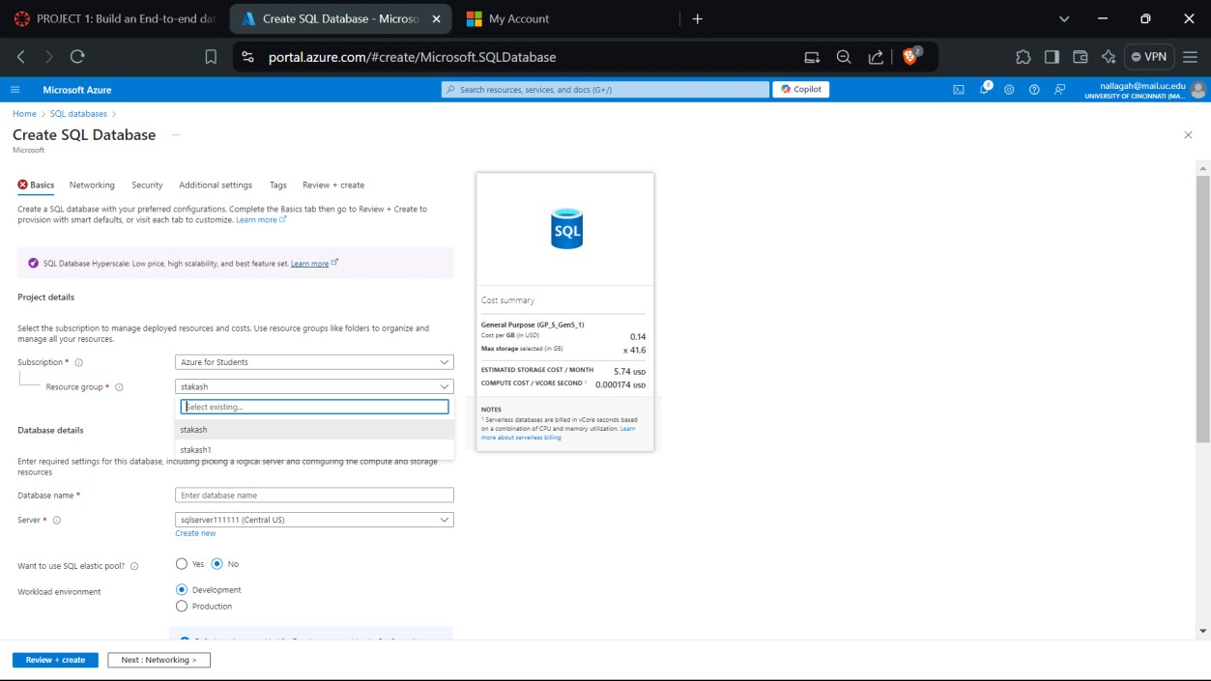

## SS 7:- DEPLOYMENT SCREEN

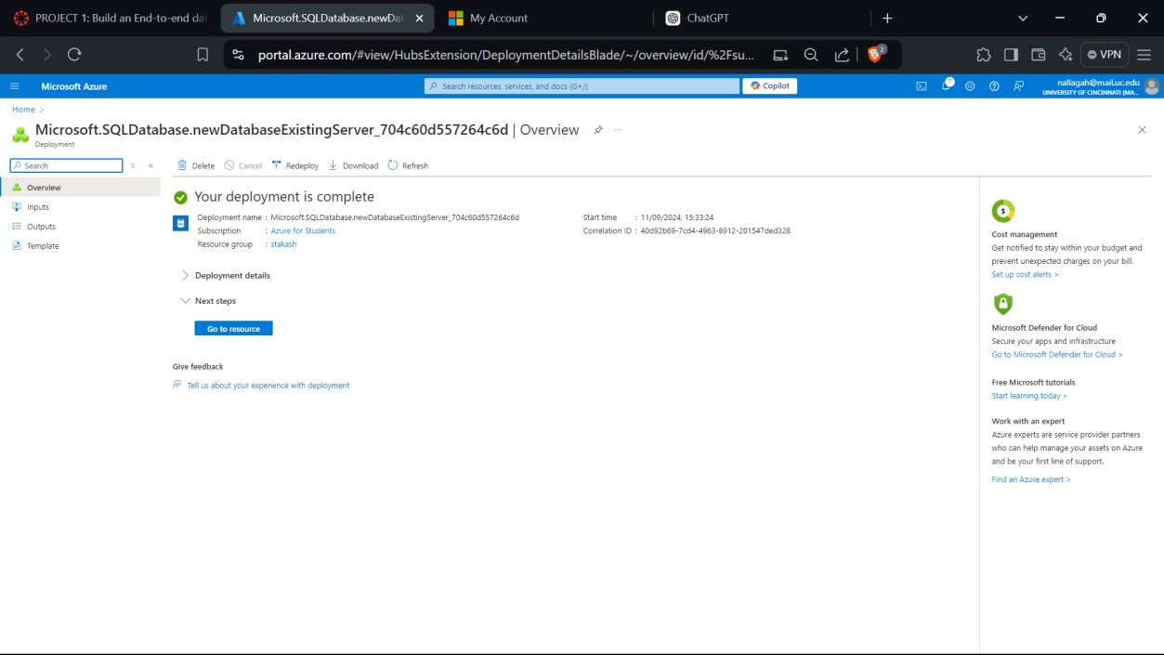

**SS 8:- SQL SERVER**

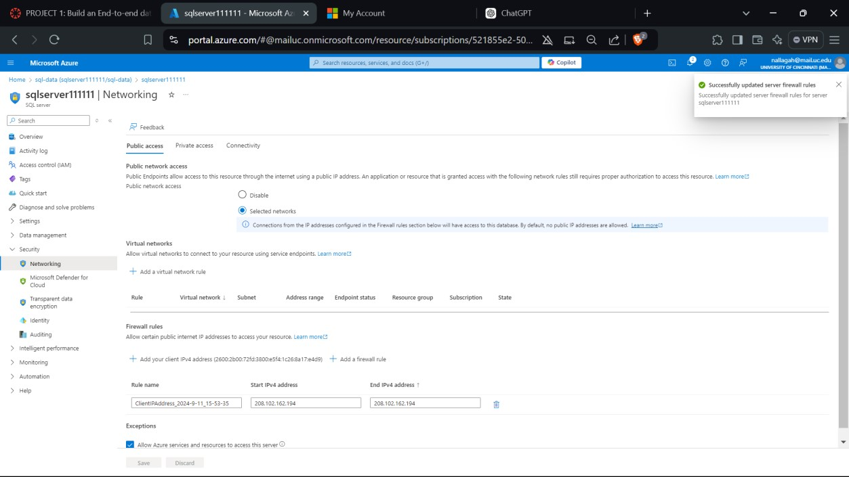

## SS 9:- SERVER LOGIN

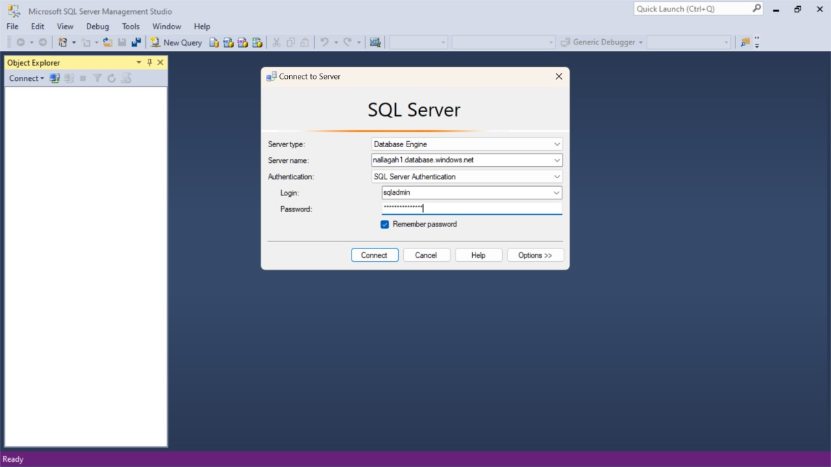

## SS 10:- CREATION OF TABLE

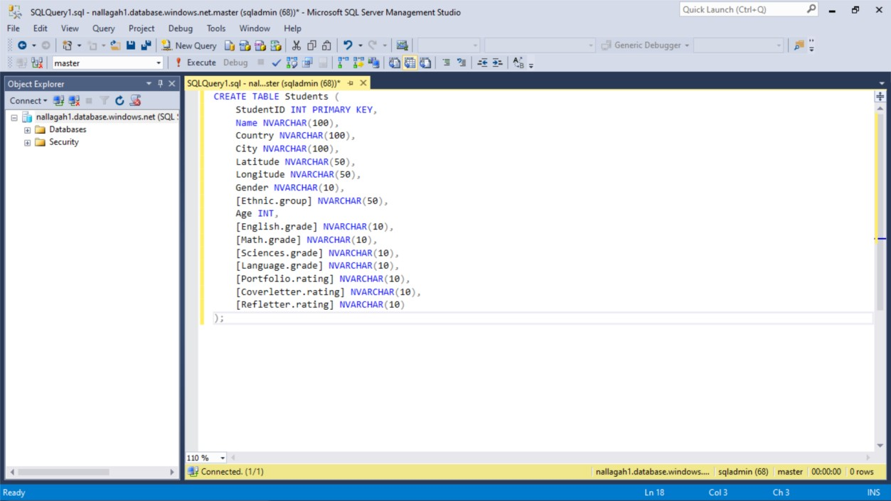

## SS 11:- AZURE DATA FACTORY STUDIO CR4EATION

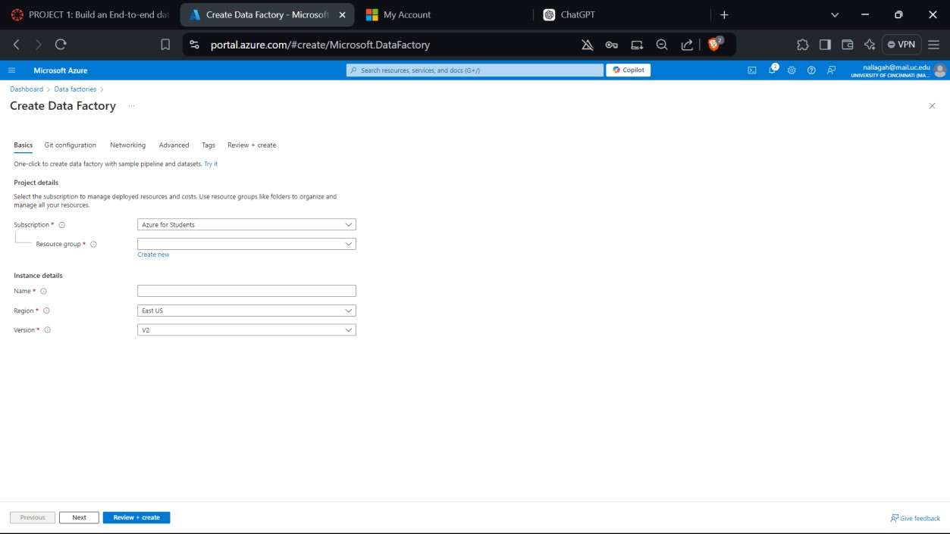

## SS 12:- ADF DASHBOARD

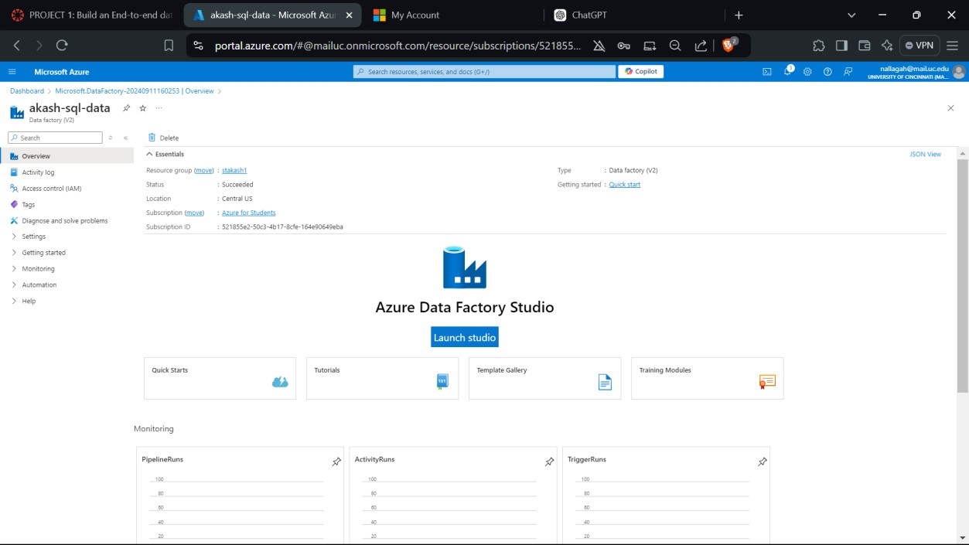

## SS 13:- CREATION OF BLOB STORAGE

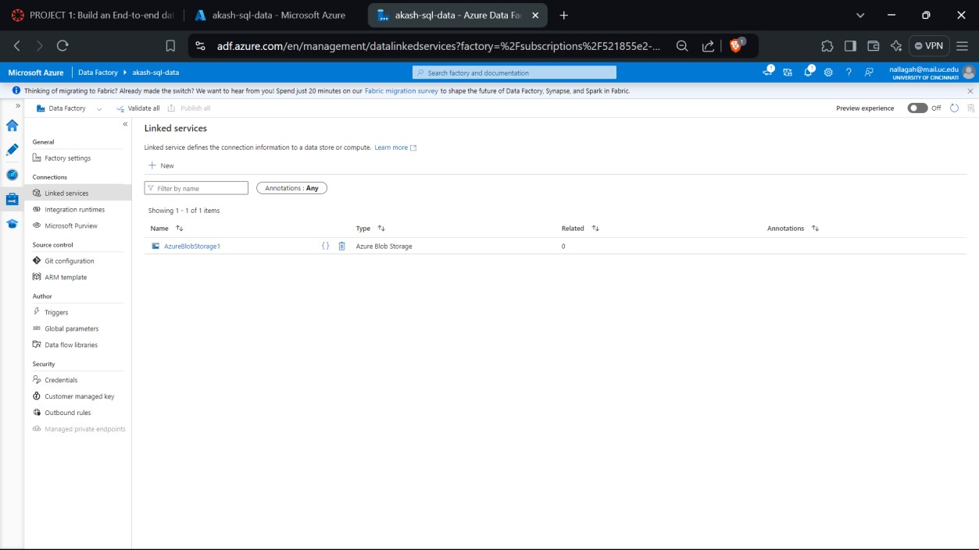

## SS 14:- CREATION OF AZURE SQL DATA

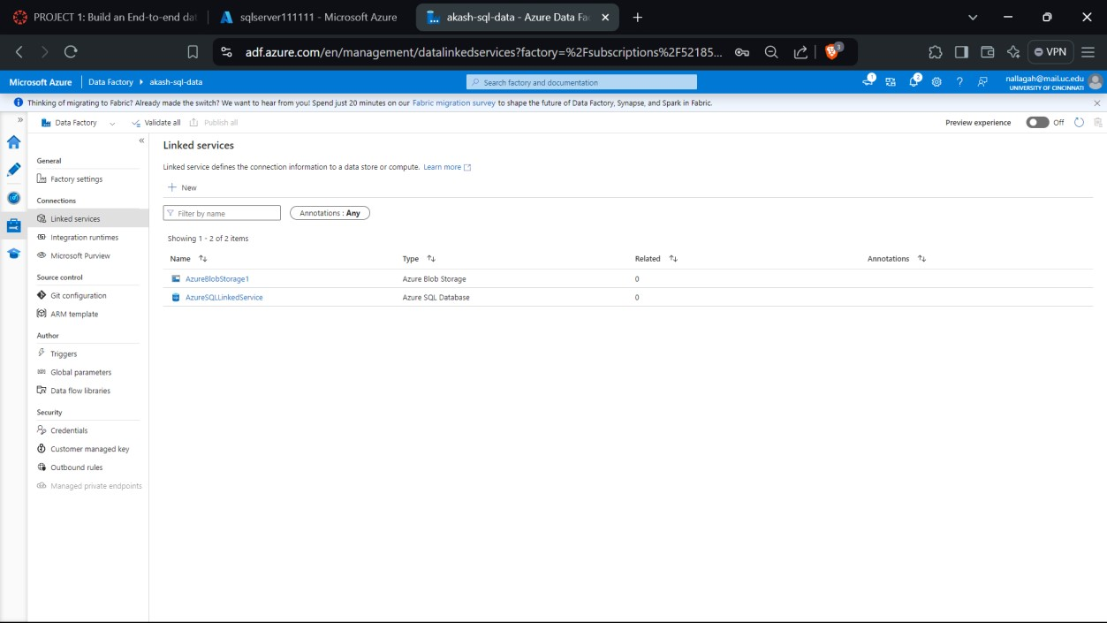

## SS 15:- CREATION (STUDENTCSV) FILE

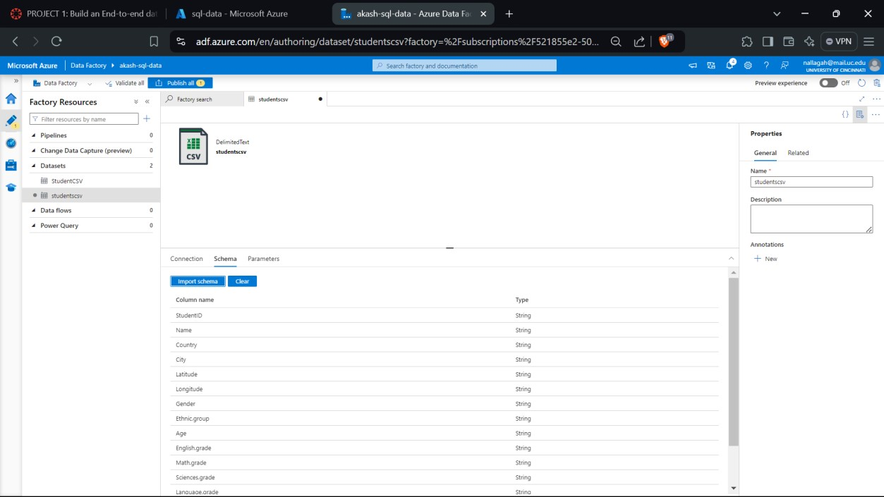

**SS 16:- CREATION OF PIPELINE AND DEBUGGING.**

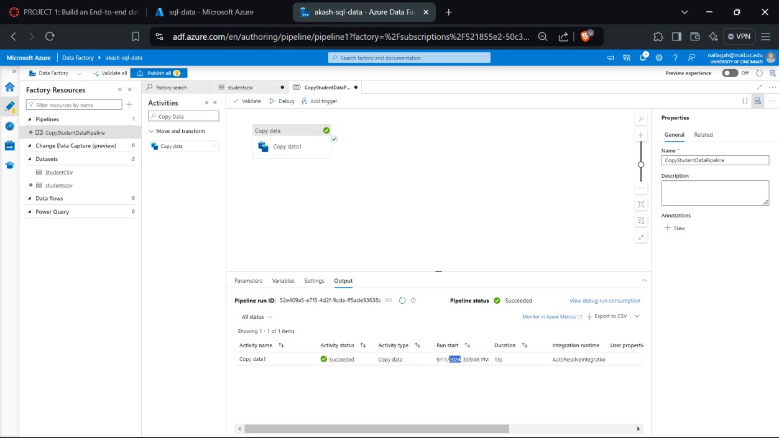

# FINAL RESULT

## SS 17:- QUERYING (STUDENT COUNT BY COUNTRY)

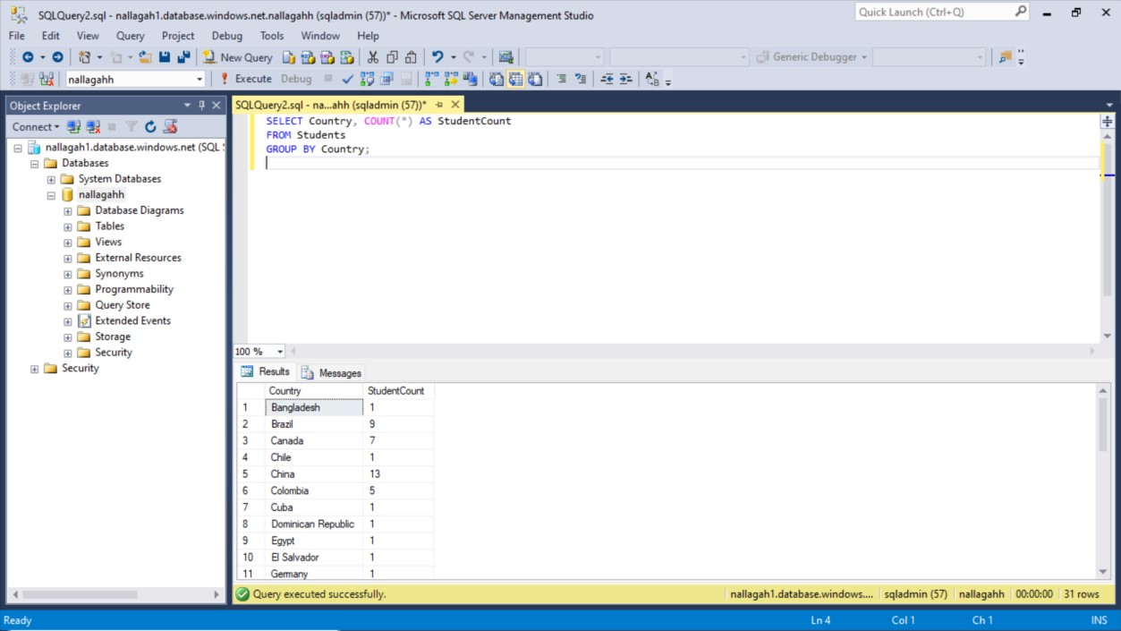

## FUNCTION APP

**SS1:- CREATE FUNCTION APP**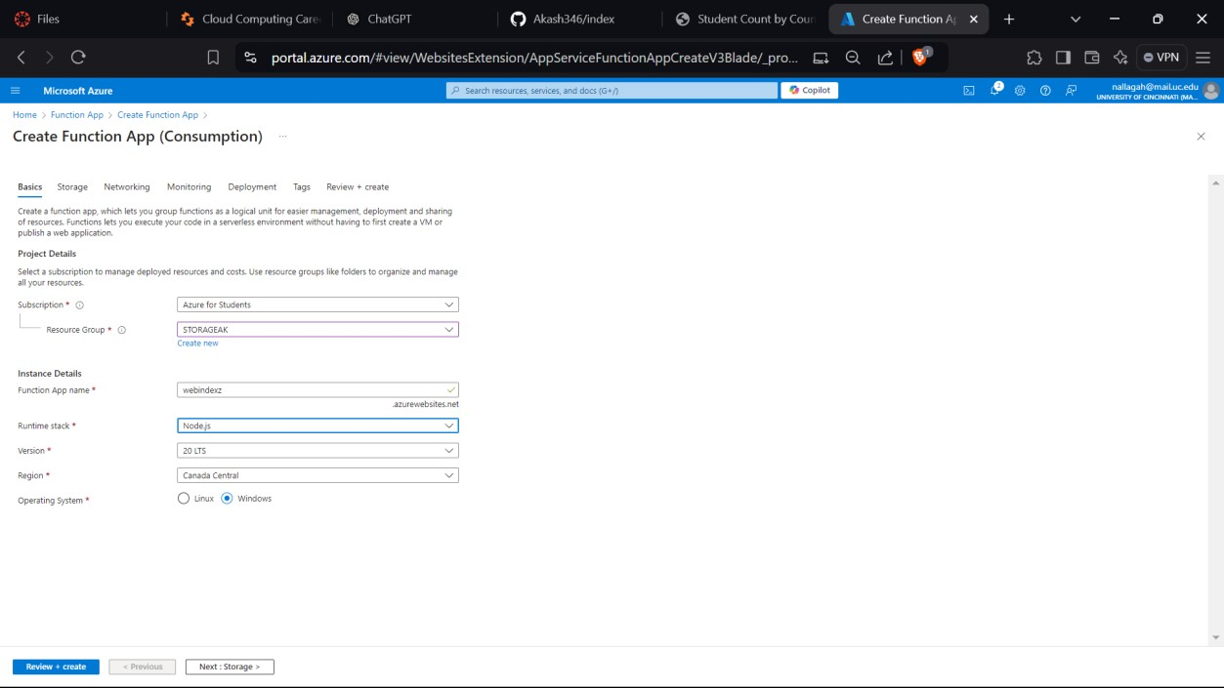

**SS2:- CREATE HTTP TRIGGER TEMPLATE.**

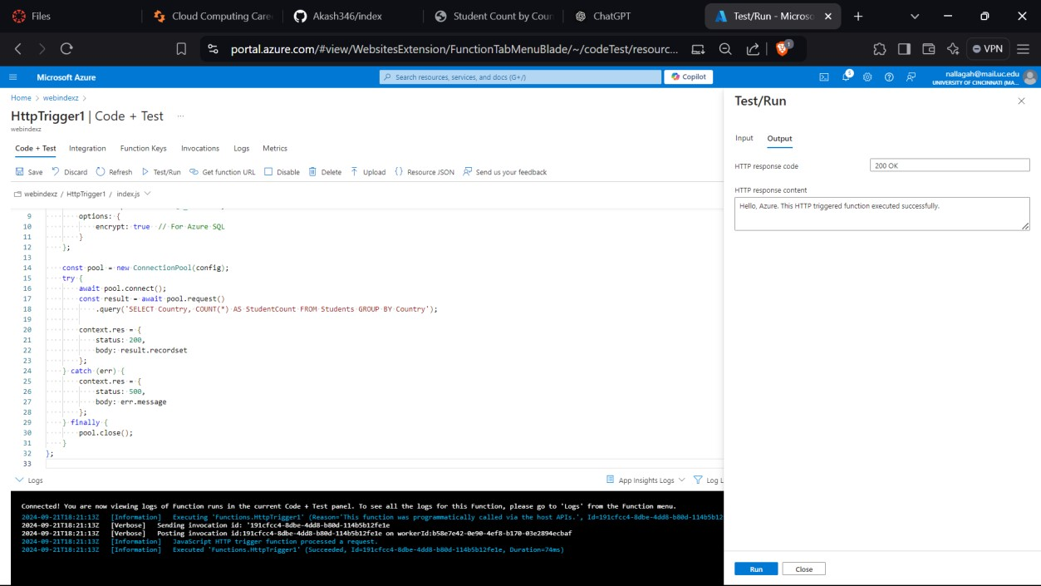

**SS3:- DEPLOYED HTTP TRIGGER TEMPLATE**

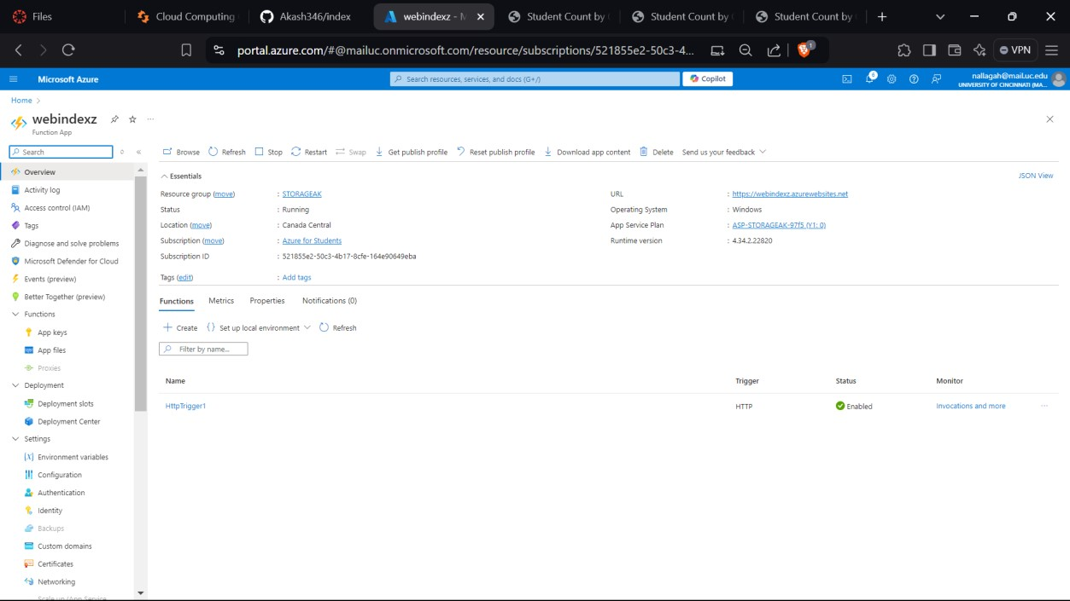

**S4:- STATIC WEBAPP**

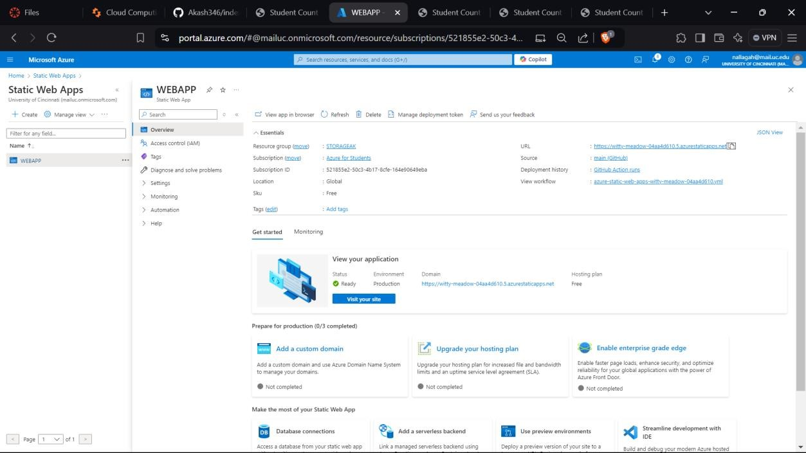

**SS5:- FINAL RESULT(STUDENT COUNT BY COUNTRY IN A LINK)**

